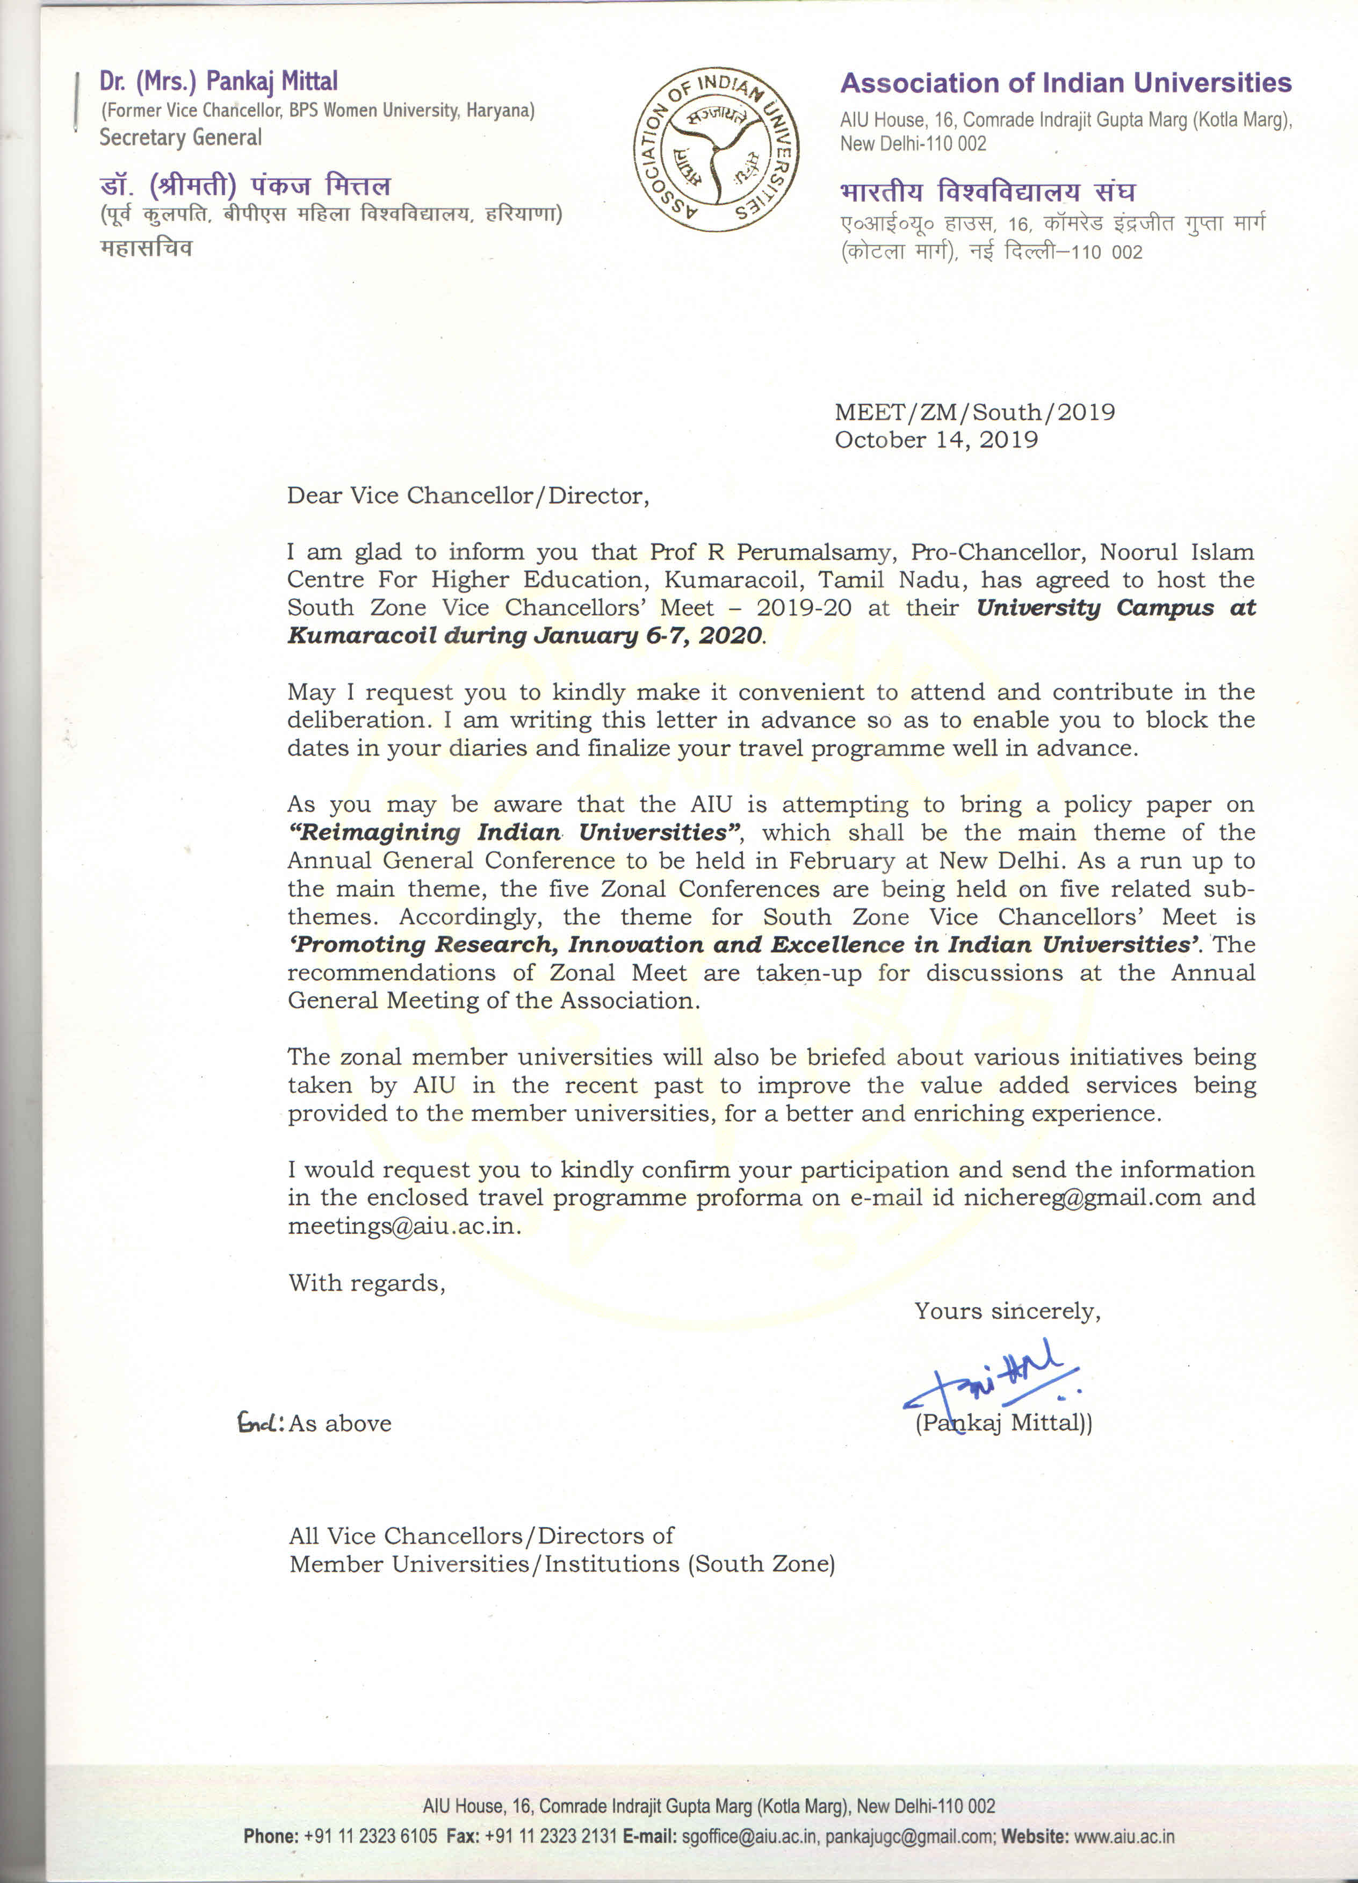

ASSOCIATION OF INDIAN UNIVERSITIES
SOUTH ZONE VICE CHANCELLORS’ MEET-2019-20

Venue: | Noorul Islam Centre For Higher Education  (Deemed to be University)  Kumaracoil-629180  Dist.- Kanyakumari (TN) | Dates | January 6-7, 2020
Please send a copy of the travel proforma through e-mail to:

Dr. P. Thirumalvalavan  Registrar  Noorul Islam Centre For Higher Education  (Deemed to be University)  Kumaracoil-629180  Dist.- Kanyakumari (TN)  Phone: 04651-251766  Mobile: 9443752498  Email: nichereg@gmail.com; | Dr. Alok Kumar Mishra,  Joint Secretary (Meetings)  Association of Indian Universities,  AIU House, 16, Comrade Indrajit Gupta Marg,  New Delhi 110 002  (e-mail: meetings@aiu.ac.in;  Fax: 011-23232131; Tel: (O) 011-23230059 Ext.235/205  Mob: 98687 48575/96679 68575).

1 | Name of the Member &  University/Institute
 |  | Phone No.(O) (R )
 |  | FAX No.
 |  | E-mail
 |  | Mobile No.
2 | Mode of Travel | Air / Train / Road
3 | Date of arrival at Thiruvananthapuram | Flight /Train No.  Date :  Time :
4 | Date of departure from Thiruvananthapuram. | Flight/Train No
Date

Time :

5 | Whether accommodation required at Thiruvananthapuram? | Yes No
6 | Dietary restrictions, if any.
7 | Any other information/assistance required.

Date: Signature of Member

Place

